This document is a template to allow you to draft your project proposal offline.
Please submit your actual project proposal via the online form: https://curtin.au1.qualtrics.com/jfe/form/SV_9WuPvBeAUuvySmq
Due to the large number of submissions we receive, we cannot accept proposals in DOCX or PDF format.

HIVE Summer Internship Project Proposal 2024-25

Q1.2 Primary Academic Supervisor (Must be a Curtin academic staff member)

Insert text here

Q1.3 Primary Supervisor's Curtin email address

Q1.4 Co-Supervisor/s
Co-supervisor name

Co-supervisor email

Second Co-supervisor name

Second Co-supervisor email

Third Co-supervisor name

Third Co-supervisor email

Q1.5 Criterion 1
Well defined project
Please word your project for promotion to prospective intern students.
Outstanding proposal | Unsatisfactory proposal
Contains clear project outcomes | Contains unclear project outcomes
Original project | Repeat project
Well defined description | Description not well defined
Written to inspire interest from students

See Appendix A for a hint on how to check word and character counts in Word.

Q1.6 Project Title (max 100 characters)
This title will be used for promotion to prospective intern students

Q1.7 Project Background (max 2000 characters)
Describe the background and research that you are working on, that will help students understand the topic of this project.

Q1.8 Project Description, Expected Outputs, Possible Stretch Goals (max 2000 characters)
Please describe the aim of the internship project and what visualisation outputs you hope the student can produce.

Q1.9 Links to background reading and any relevant recent work in the field. (at least 3 links)

Q1.10 Criterion 2
Focus on research outcomes, use of HIVE facility, and application of visualisation.
If you are not sure, please contact HIVE@curtin.edu.au
Outstanding proposal | Unsatisfactory proposal
Obvious use of HIVE facilities | Project does not use HIVE facilities
Focused on visualisation outputs | No visualisation outputs
The project will contribute to research outcomes | Project not research outcome focused

Q1.11 What type of visualisation will the student develop or produce? (500 character limit)

Q1.12 How will the visualisation contribute to your research outcomes? (500 character limit)
For example: what outcomes are expected; what will be done to achieve the outcomes and how will it be done

Q1.13 If the project is successful, where would you consider publishing the results?

Q1.14 HIVE display/s to be utilised
Please select which HIVE display will likely to be used for visualisation to provide most impact
- Cylinder
- Wedge
- Dome
- Hologram Table
- Tiled
- Looking Glass Portrait
- Looking Glass 15.6"
- 3D PluraView
- Not Applicable

Q1.15 HIVE VR/AR equipment to be used
Please select which HIVE equipment you're likely to use for loan on the project
- Quest Pro
- Quest 2
- Quest 3
- HTC Vive Pro
- HoloLens 2
- Tilt Five
- Apple Vision Pro
- Not Applicable

Q1.16 HIVE Licenced software to be used
HIVE already have licences for the following software. Please indicate if you'd like to use any of these software for your project
- Photoscan/Metashape
- 3DM analyst
- Other (please indicate)

- Not Applicable

Q1.17 Other HIVE equipment to be used?
- Canon VR 180 lens
- Canon 5D
- RED Scarlet
- Fish eye lenses
- GoPro MAX 360
- Sony/Panasonic 3D HD video cameras
- Not Applicable

Q1.18 What additional software is likely to be used for the project?
For example: 3D Slicer; Luma AI; ArcGIS; etc.

Q40 What additional hardware is likely to be used for the project?
For example: HIVE laptop; accessories; etc.

Q1.19 Criterion 3
Suitable scope of work for intern and time scale of project
If you are unsure as to what would be required to produce your visualisations, please contact HIVE@curtin.edu.au.
Outstanding proposal | Unsatisfactory proposal
2-4 milestones to guide progress | No milestones
Scope of project is feasible in 10 weeks | Not feasible in 10 weeks
Concise weekly task list that clearly shows how student will learn and develop research skills | No detail to weekly timeline

Q1.20 Draft Project Timeline
Please summarise what the student will do week-by-week.
Week 1 - Nov 11
Nov 11 - Full day HIVE induction
Nov 12 - Area and Project Induction with Primary supervisor
Develop project plan with HIVE and academic team
Literature and relevant project review

Week 2 - Nov 18

Week 3 - Nov 25

Week 4 - Dec 2

Week 5 - Dec 9

Week 6 - Dec 16

Week 7 - Jan 6

Week 8 - Jan 13

Week 9 - Jan 20
Focus on report writing and presentation preparation

Week 10 - Jan 27
31st Jan Final Presentation Showcase Day and final report due

Page Break

Q1.21 Criterion 4
Student experience and supervision
Outstanding proposal | Unsatisfactory proposal
Appropriate computer available | No allocated computer
At least 1 official meeting per week | No planned contact with academic supervisor
Desk available for student to work in close proximity to Academic Supervisor | No allocated desk

Q1.22 How often will you meet with the intern student over the 10 week period?
(once per week minimum)

Q1.23 Your work desk location and the location of student desk
(please indicate building and room numbers)

Q1.24 Computer allocated for project
(please indicate CPU/GPU specifications of computer you will provide for student use)

Q1.25 Please indicate any leave plans for ALL supervisors over the internship period

Q1.27 Student Attributes
When matching students to successful projects, we will look for the attributes you include below.
If you are not sure, please contact HIVE@curtin.edu.au

Q1.28 Please indicate any preference for intern student's academic discipline or field of study (e.g. Computer Science, Film, Design)
If the field the student is studying is not a factor for your project, please enter N/A.

Q1.29 What competencies are required to start this project.
Please remember internships are intended to give students learning and development opportunities. If you are not sure, please contact HIVE@curtin.edu.au to discuss.
 | Not Applicable | Beginner | Intermediate | Advanced
2D image and/or video software (e.g. Adobe Suite, Sony Vegas)
3D modelling software (e.g. Blender, 3ds Max)
Unity 2D/3D Artistry (assets, lighting, cameras, materials implementation)
Unity Programming (C# coding, animation syntax, debugging, problem-solving)
Unity Virtual Reality Development (rendering pipelines, scene content design, interaction)
Data structures, analytics, statistical modelling
Other capability, please describe
Other capability, please describe

Q1.30 Do you have any other student attributes you think are important to the project?

Q1.31 Additional project information

Q41 Ethics
All research on humans conducted on Curtin campuses or by Curtin students or staff must be approved by the Curtin Human Research Ethics Committee before it can commence. Please indicate whether ethics approval is required for your project. Further information is available at Human Research Ethics
- Yes
- No
- Unsure

Q42 Dataset
Please indicate whether dataset for this project exist. If not, will it be collected as part of this project and how

Q1.32 Project sponsors
Will you or a third party contribute to the funding for this student and/or HIVE support? Five funded scholarship places are available via the HIVE internship program which are competitively allocated.
If you have at least $7k for internally generated research projects (HIVE absorbs support costs), or $12k for industry generated projects, please advise as this will go toward guaranteeing the project if the proposal meets the 4 criteria.

Q1.33 Do you have any specific students in mind?
If so, please indicate first name, last name and student email address. Please indicate with * if you will only accept this student.

Q1.34 Industry Collaborators
Please indicate any industry collaboration in the project and the role they will play (please be clear whether confirmed or prospective)

Q1.35 Are there any data or IP confidentiality constraints? If so, please detail.
For example: ownership or restrictions on intellectual property of data or software

Q1.36 Are there any special restrictions on the developed visualisations or software?
For example: commercial-in-confidence; patent submission; etc.

Q1.37 Can the HIVE use visualisations from the project to promote the results of the project?
- Yes
- No
- It's complicated, here's why

Q1.38 Will you acknowledge the HIVE and assigned HIVE staff member/s in project/research outputs.
- Yes
- No
- It's complicated, here's why

Q1.39 Is there anything else we should know about?

Appendix A:

How to see the “word count” and “character count” in real-time in Word:

In Microsoft Word, right-click on the bottom information bar (see below). On the list that pops up, turn on “Word Count” and “Character Count (with spaces)”. This will then show the number of words and characters in the document (or the selected region).

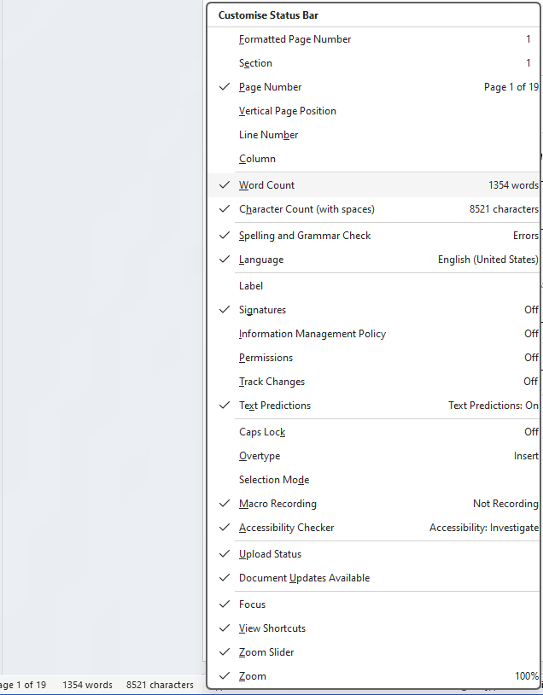
2. If not aready enabled, please enable “Word Count” and “Character Count”
- The number of words and characters should now be displayed on this information bar.
- Right-click on this information bar

